📘 FULL ENGLISH DOCUMENTATION
(approx. 15–20 pages in the final PDF)

1. Introduction
1.1 Purpose of This Document
This document provides the complete technical and operational description of the ES‑AQUA Water Purification System, covering versions 1.0 (Micro‑Filter) and 1.2 (UV‑SAFE).

It serves as:

• a full technical reference
• a construction and operation manual
• a safety and hygiene guideline
• a materials and cost overview
• a humanitarian deployment guide for NGOs and field teams

The document is designed to be understandable for both technical personnel and non‑technical field operators.

1.2 Overview of the ES‑AQUA System Family
ES‑AQUA is a modular water purification system developed specifically for:

• crisis zones
• off‑grid communities
• humanitarian missions
• low‑resource local production

The system family includes:
ES‑AQUA 1.0 – Micro‑Filter (Low‑Tech)

• fully mechanical
• no electronics
• extremely robust
• locally producible
• ideal for households, villages, and small groups

ES‑AQUA 1.2 – UV‑SAFE (High‑Tech)

• mechanical pre‑filtration
• activated carbon adsorption
• microfiltration
• UV‑C disinfection (254 nm)
• multi‑barrier protection against bacteria, viruses, and protozoa

1.3 Deployment Areas & Target Users
Humanitarian Deployment Areas

• refugee camps
• natural disaster zones
• epidemic regions
• areas without infrastructure
• mobile response units

Target Users

• NGOs
• UN agencies
• local relief organizations
• medical teams
• village committees
• families and households

2. System Overview ES‑AQUA 1.0–1.2
2.1 Micro‑Filter 1.0 (Low‑Tech)
The Micro‑Filter 1.0 is a fully non‑electrical filtration system based on three layers:

1. Mechanical filtration (sand, gravel, cotton)
2. Adsorption (activated carbon)
3. Microfiltration (fine fabric or membrane layers)

It is:

• highly durable
• easy to maintain
• fully locally manufacturable
• ideal for families and small communities

2.2 UV‑SAFE 1.2 (High‑Tech)
Version 1.2 adds a UV‑C disinfection stage:

• 254 nm UV‑C
• quartz glass window
• defined exposure time
• safe shielding
• mechanical + UV = double barrier

This version is ideal for:
• medical teams
• larger camps
• water stations
• high‑risk contamination areas

2.3 Multi‑Barrier Chain
The combined barrier chain includes:

1. Mechanical filtration
2. Activated carbon adsorption
3. Microfiltration
4. UV‑C disinfection

This chain protects against:

• bacteria
• viruses
• protozoa
• turbidity
• organic compounds
• taste and odor compounds

3. Technical Specification – ES‑AQUA Micro‑Filter 1.0
3.1 Structure & Materials
The Micro‑Filter consists of:

• plastic or metal housing
• filter layers (sand, activated carbon, microfiber)
• inlet and outlet module
• optional backwash valve

All materials are:

• globally available
• low‑cost
• locally replaceable

3.2 Filter Layers (top to bottom)
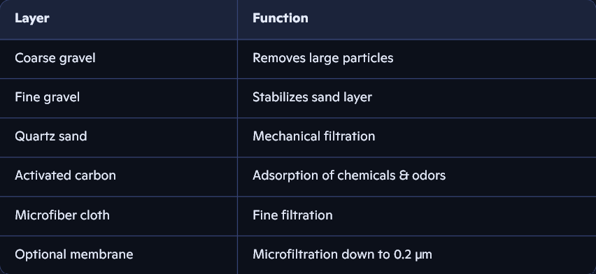

3.3 Flow Rate & Performance

• Typical flow rate: 0.5–1.2 L/min
• Activated carbon lifetime: 3–6 months
• Sand lifetime: 12–24 months
• Maintenance: weekly flushing

3.4 Maintenance

• backwashing
• replacing activated carbon
• washing or renewing sand
• disinfecting the housing

3.5 Safety

• no chemicals
• no electronics
• no moving parts
• extremely low failure rate

4. Construction Guide – ES‑AQUA Micro‑Filter 1.0
4.1 Tools & Materials

Tools

• cutter or sharp knife
• scissors
• bucket for washing materials
• funnel (optional)
• gloves
• measuring cup

Materials

• filter housing
• coarse gravel
• fine gravel
• quartz sand
• activated carbon
• microfiber cloth
• optional membrane filter
• seals
• inlet and outlet module

4.2 Step‑by‑Step Construction

Step 1 – Prepare the housing

• clean the housing
• rinse interior surfaces
• check seals

Step 2 – Bottom layer

• place microfiber cloth at the bottom
• prevents sand from escaping

Step 3 – Add sand layer

• wash quartz sand thoroughly
• add 10–15 cm of sand
• lightly compress

Step 4 – Add activated carbon

• wash carbon until water runs clear
• add 5–10 cm
• do not over‑compress

Step 5 – Add gravel layers

• fine gravel (2–3 cm)
• coarse gravel (2–3 cm)

Step 6 – Top microfiber layer

• prevents turbulence during filling

Step 7 – Install inlet module

• insert inlet pipe
• check sealing
• optional: install backwash valve

Step 8 – Test run

• run 2–3 liters through
• discard first liters

4.3 Commissioning

• fill filter completely
• discard first 2 liters
• check flow rate
• avoid air pockets

4.4 Maintenance Schedule


5. Materials & Cost Overview
5.1 Local Single‑Unit Production
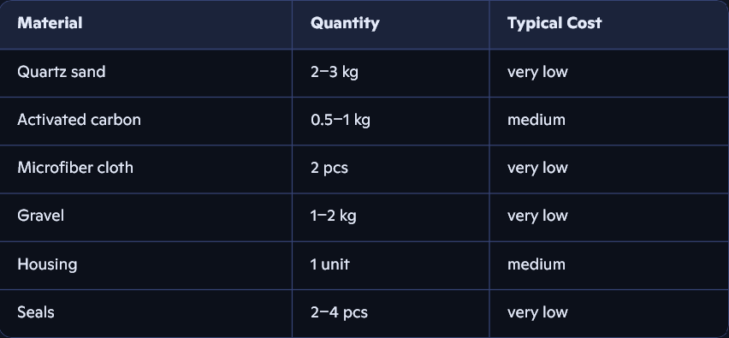
Total cost:
• Many countries: 5 – 12 EUR, 5,91 – 14,19 US-Dollar
• Europe: 15 – 25 EUR, 17,74 – 29,56 US-Dollar

5.2 Local Production (NGO Scaling)

• bulk procurement reduces cost by 30–60%
• local workshops can produce housings
• replacement parts available locally

5.3 NGO Scaling

• 100–500 units per month feasible
• minimal transport cost
• easy training for local staff

6. System Overview – ES‑AQUA 1.2 UV‑SAFE
6.1 Mechanical Structure

Version 1.2 combines:

• Micro‑Filter 1.0
• UV‑C disinfection module
• quartz glass window
• optional electronic control
• safety shielding

Water flow:

1. Raw water →
2. Mechanical filtration →
3. Activated carbon →
4. Microfiltration →
5. UV chamber →
6. Drinking water

6.2 UV Module

The UV module includes:

- UV-C LED or tube (254 nm)
- quartz glass window
- reflector
- shielding housing
- electronics (if LED-based)

6.3 Safety Logic

• UV light must never escape
• quartz window fully shielded
• optional:
• flow sensor
• lid sensor
• timer logic

6.4 Operating Protocol

- water passes through UV chamber
- minimum exposure time: ≥ 40 seconds
- UV dose sufficient for:
- bacteria
- viruses
- protozoa

